Towns and cities

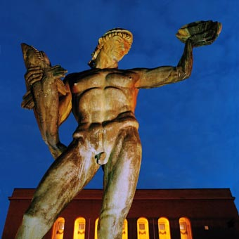 Poseidon in Gothenburg

Match the city with the correct alternative

a) Turkey

b) Sweden

c) Italy

d) Romania

The correct alternative is: b.

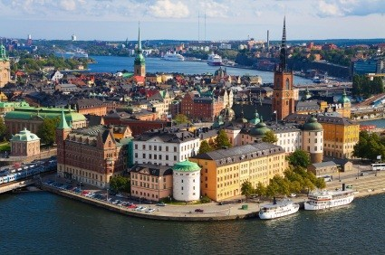 Riddarholmen in Stockholm

Match the city with the correct alternative

a) Sweden

b) Poland

c) Spain

d) Bulgaria

The correct alternative is: a.

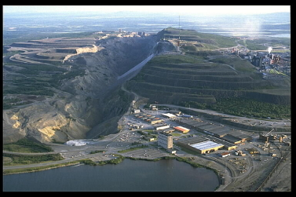 The Kiruna mines

Match the city with the correct alternative

a) Poland

b) Italy

c) Turkey

d) Sweden

The correct alternative is: d.

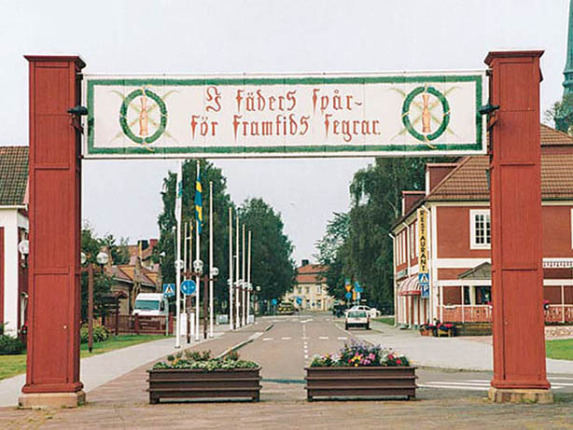 The goal gate of Vasaloppet in Mora

Match the town with the correct alternative

a) Spain

b) Sweden

c) Italy

d) Bulgaria

The correct alternative is: b.

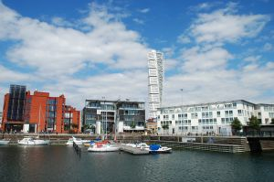 Malmö from the sea

Match the city with the correct alternative

a) Romania

b) Spain

c) Sweden

d) Turkey

The correct alternative is: c.